________________________________

Monitoring Reporting and Verification -MRV
Use case for
Carbon Cockpit

Version 1.0
Prepared by: Gold Standard
October 2017

Revision History

Revision No. | Date | Change Description
1 | 31 Oct 2017 | Initial

Tracking flows of attributes of energy (Voluntary Emission Reductions (VERs) credits or Renewable energy certificates (RECs))

Problem statement
Renewable energy projects (wind, solar etc.) sell the generated electricity to the consumers via grid and claims attributes such as VERs or RECs for verified generated electricity via third party certification. The certification agencies issue these attributes with unique IDs, which transacted via registry system several times, before claimed by the end buyer or consumer. At a time, only one attribute (either VERs or RECs) should be issued to the generated electricity (MWh). Issuance of different attributes for the same MWh is a risk due to decentralized issuance of certificate by different agencies.

The challenge is to develop a platform to track issuance and flows of attributes linked with the MWh generated to avoid double issuance or over issuance.

Process flow
The following provides a simplified process flow for energy and its attributes.
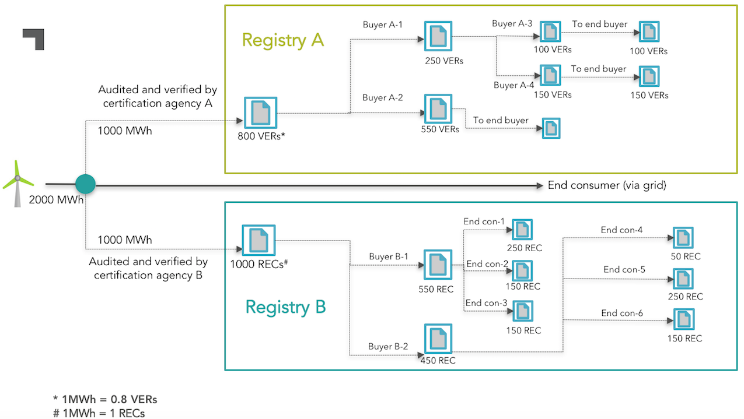

Though this use case focuses on flows of attributes of energy, the monitoring reporting and Verification (MRV) and attribution of environmental characteristics is more broadly applicable in other environmental markets.

What is expected:
- Auto-tracking of issuance of each attributes vs MWh generated to ensure no double issuance or over issuance takes place.
- Track GS-VERs/ RECs transactions among stakeholders who buys and uses these attributes.

